France’s plans for the Louisiana Territory:
France plans to use the Louisiana Territory to grow crops, ship the crops to their island of Haiti, and feed the slave population. That way they won’t waste land that is good for growing sugar cane to grow crops.
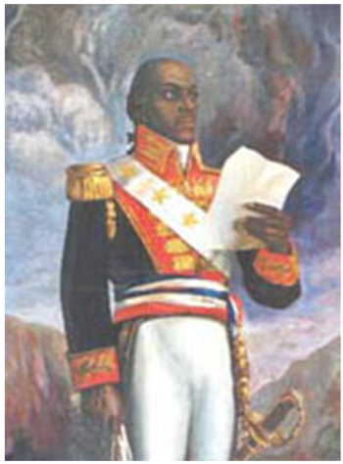
Toussaint L’Ouverture
But former slave Toussaint L'Ouverture leads a
slave revolt in Haiti, West Indies. He is captured
in 1802, but the revolt continues and Haitian
independence is declared.

Southerners are terrified by these events as they fear a slave revolt may happen in the US.

France no longer needs Louisiana to grow crops to
feed the slave population in Haiti.

